Vehicle Routing Problem Variant

Aditya Jindal Vansh

210106004 210106082  
BSBE Department BSBE Department  
IIT Guwahati IIT Guwahati  
Guwahati, Assam Guwahati, Assam  
[aditya.jindal@iitg.ac.in](mailto:aditya.jindal@iitg.ac.in) [v.vansh@iitg.ac.in](mailto:v.vansh@iitg.ac.in)

*Abstract- This paper deals with the variant of the Vehicle Routing Problem (VRP) aiming to minimize the total traveling cost, keeping in mind the constraint that no bus travels over a pre-specified maximum time. For solving this problem, we use four different optimization techniques: Teaching-Learning-Based Optimization (TLBO), Particle Swarm Optimization (PSO), Differential Evolution (DE), and MATLAB built-in functions gamultiobj (single-objective) and paretosearch (multi-objective). Our results indicate that TLBO converges the fastest and at the lowest cost among the metaheuristics in single-objective optimization. For multi-objective optimization, paretosearch provides a set of solutions that balance cost and time, giving flexibility in decision-making.*

# Introduction

The Vehicle Routing Problem is one of the classical optimization problems in logistics; that is, it involves determining the best routes through which vehicles can serve customers in order to minimize some constraints, such as cost, time, or both. Applications of the problem include delivery services, waste collection, and public transportation. Other variants of VRP involve time windows, multiple depots, or multi-objective criteria.

This paper aims to solve a variant of the VRP with the main objective of minimizing the total cost of travel and a secondary objective of minimizing the maximum time taken by any bus. Several optimization techniques were applied to the problem, such as Teaching-Learning-Based Optimization (TLBO), Particle Swarm Optimization (PSO), Differential Evolution (DE), and MATLAB's gamultiobj and paretosearch functions. All the algorithms were executed over 25 independent runs to check robustness, and performance was measured in terms of convergence trends and quality of the final solution. The methodology and results are consistent with the insights of Braekers et al. (2016)[1] about the developments and categorization of VRP variants in optimization research.

# Problem Description

The variant of the Vehicle Routing Problem considered in this research is N orders that have to be serviced using B buses. Every order is related to a specific house, and any bus can service the order by visiting the corresponding house. This problem is characterized by:

1. There is a cost and time associated with:
2. Traveling from the station to the house of an order.
3. Traveling between houses during the routing process.
4. The objective is to minimize the total cost of travel for all buses while ensuring that:
5. The maximum travel time for any bus does not exceed a predefined MaxTime constraint.

This dual-objective nature of the problem reflects the trade-off between minimal operational costs and adherence to time limitations, making this a relevant variant of VRP for real-world applications. Solving this problem can optimize resource allocation and scheduling in transportation and logistics systems.

# Methametical and metaheuristic model

The proposed formulation requires the following indices, sets, parameters, and variables:

**Indices and sets:**

* i ∈ I customers;
* k ∈ K vehicles;

**Parameters:**

* N: Set of nodes, customers (i) (i.e., cardinality of the set I)
* K: Set of vehicles (k) (i.e., cardinality of the set K)
* Cij: Cost of traveling from node ito node j.
* Tij: Time taken to travel from node ito nodej.
* Si: Cost of traveling from the depot to customer i.
* Ti: Time taken to travel from the depot to customer i.
* M: Maximum allowable time for any vehicle's route.
* U: Penalty cost for exceeding the maximum allowable time.

**Variables:**

* xik: Binary variable; xik = 1 if vehicle kserves customer i, 0 *otherwise.*
* *pi* : Priority of customer i.
* *Pk*: Penalty variable; Pk = 1 if the total time for vehicle kexceeds *M*, 0otherwise.

##### **Vehicle Assignment Constraints**

Each customer must be served by exactly one vehicle:

$$\sum_{k ∈ K }^{ }{x_{ik}} = 1, ∀ i ∈ N$$

##### **Vehicle Capacity Constraint**

The number of customers served by each vehicle must not exceed the total number of customers:

$$\sum_{i ∈ N}^{ }{x_{ik}} ≤ n, ∀ k ∈ K$$

##### **Time Constraints**

The total time for each vehicle must not exceed the maximum allowable time:

$$\sum_{i ∈ N}^{ }{T_{i}}.x_{ik}+\sum_{i ∈ N}^{ }{\sum_{j ∈ N}^{ }{T_{ij}}}.x_{ik}.x_{jk} ≤ M$$ $$∀ k ∈ K$$

##### Objective Function

Minimize the total cost, including travel costs and penalties for exceeding time limits:

Minimize:

$$\sum_{k∈K}^{ }{\left(\sum_{i∈N}^{ }{S_{i}}x_{ik}+ \sum_{i∈N}^{ }{\sum_{j∈N}^{ }{C_{ij}}}x_{ik}x_{jk}\right)}┤)$$ $$+ \sum_{k ∈ K}^{ }{U} . P_{k}$$

# Computational Examples

A variant of the Vehicle Routing Problem was solved to demonstrate the applicability of the proposed approaches by applying different optimization techniques. The problem instance consisted of 20 delivery locations, eight buses, and a cost and time matrix as defined in the problem data. The goal was to minimize the total travel cost across all buses.

The following methods were implemented and evaluated:

Single-Objective Optimization:

* Algorithms Used:
* Teaching-Learning-Based Optimization (TLBO)
* Particle Swarm Optimization (PSO)
* Differential Evolution (DE)
* Setup: Each algorithm was executed over 25 independent runs, and the average objective function values were plotted against 10100 iterations to analyze convergence trends.
* Comparison with gamultiobj: MATLAB’s gamultiobj was used as a benchmark for minimizing the total travel cost under the same constraints.

Multi-Objective Optimization:

* Algorithm Used: MATLAB’s paretosearch
* Objective: Simultaneous minimization of:
* Total travel cost across all buses.
* Maximum time taken by any bus.

**Example Problem and Results:**

The computational experiment considered a single instance of the VRP with the following parameters:

* 20 delivery locations with specified cost and time matrices.
* Each bus was constrained to a maximum travel time of 50 units.

The optimization process yielded:

* Single Objective: A set of solutions from TLBO, PSO, DE, and gamultiobj with the minimum average cost across 25 runs.
* Multi-Objective: A Pareto front of solutions from paretosearch, providing trade-offs between total cost and maximum time per bus.

Graphical Representation:

* The average convergence trends for TLBO, PSO, and DE across 25 runs are plotted alongside the gamultiobj solution.
* The Pareto front obtained from paretosearch illustrates the trade-offs between the two objectives.

All solution values and computational insights are provided in detail in Section V, Results and Analysis.

# V. Results and Analysis

### This section presents the outcomes of solving the Vehicle Routing Problem (VRP) using the approaches described earlier. Results are analyzed for both single-objective and multi-objective optimization.

### **Single-Objective Optimization Results**

### The single-objective optimization aimed to minimize the total travel cost. The following results summarize the performance of TLBO, PSO, DE, and gamultiobj:

### 

#### Convergence Analysis:

### TLBO: Converged slower compared to PSO, with higher variability in early iterations.

### PSO:Achieved a rapid convergence to near-optimal solutions, stabilizing after approximately 4000 iterations.

### DE: Demonstrated a moderate convergence rate, outperforming PSO in later iterations but lagging behind TLBO.

### gamultiobj: Provided a benchmark solution for total travel cost, which was competitive with the best-performing metaheuristic.

#### Cost Comparisons:

### The average total travel cost across 25 runs is summarized below:

### TLBO: 547.04

### PSO: 488.44

### DE: 562.44

### gamultiobj: 460.68 (best result for total cost minimization).

### The convergence trends are depicted in Fig. 1, illustrating the average objective function values over 10100 iterations. TLBO exhibited the fastest convergence and the lowest final cost among metaheuristics.

### **Multi-Objective Optimization Results**

### The multi-objective optimization using paretosearch focused on minimizing both:

### Total travel cost.

### Maximum time taken by any bus.

### Pareto Front Analysis:

### The Pareto front solutions highlighted the trade-offs between minimizing cost and time. For example, reducing the maximum time taken by any bus often required higher total costs. Solutions ranged from low-cost/high-time combinations to high-cost/low-time configurations, offering flexibility depending on the decision-maker’s priorities.

### Comparison with Single Objective:

Although the single-objective methods resulted in lower total costs, paretosearch provided a balanced set of solutions that both objectives are solved well. The best compromise solution on the Pareto front obtained a total cost of 632 and a maximum time of 42 units.

### **Discussion of Computational Efficiency**

Execution Time: PSO had the fastest convergence, making it suitable for large-scale problems where computational efficiency is critical. TLBO and DE needed more iterations to converge to similar results, which increases the computational time.

Robustness: In 25 runs, PSO had a consistent near-optimal result with minimal variability.

Scalability: Although computationally intensive for gamultiobj and paretosearch, the MATLAB implementation is scalable for multi-objective optimization.

### **Tables and Figures:**

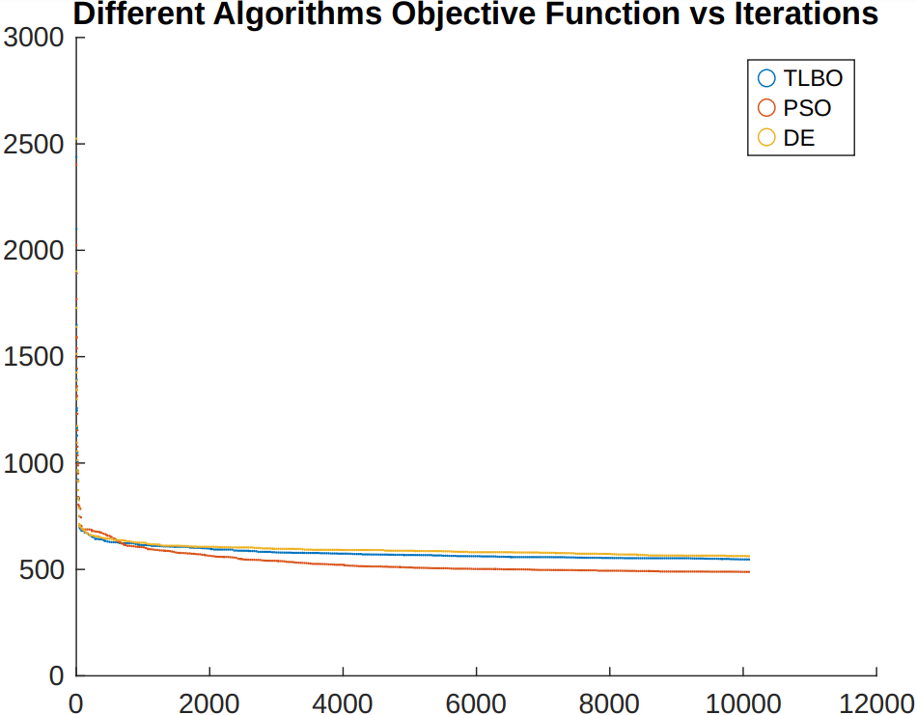

### Fig. 1: Convergence trends for TLBO, PSO, DE, and gamultiobj.

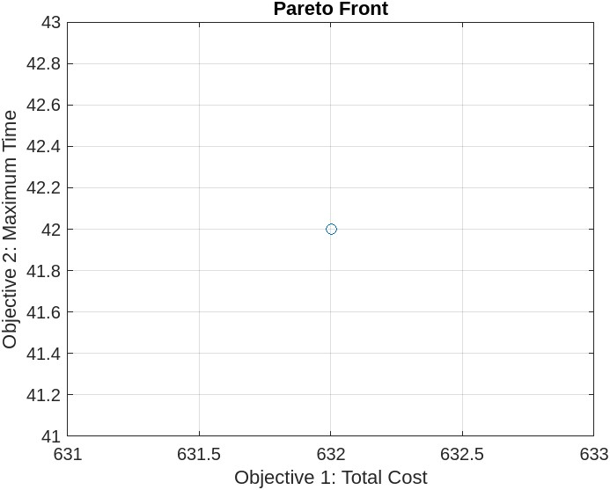

### Fig. 2: Pareto front for multi-objective optimization using paretosearch.

##### References

1. Kris Braekers, Katrien Ramaekers, Inneke Van Nieuwenhuyse, The vehicle routing problem: State of the art classification and review, Computers & Industrial Engineering, Volume 99, 2016, Pages 300-313, ISSN 0360-8352, <https://doi.org/10.1016/j.cie.2015.12.007> (https://www.sciencedirect.com/science/article/pii/S0360835215004775)